Living with Covid plan
This guidance replaces the previous Living with Covid plan (archived)
Updated May 2023

Following a review of government guidelines and feedback from our infection prevention support and advisors at East and North Hertfordshire NHS Trust Infection prevention and control team regarding their current recommendations and practices, this document has been reviewed and the following has been agreed:

- We will continue to follow the testing guidance for hospices (updated April 2023)

https://www.gov.uk/guidance/coronavirus-covid-19-testing-for-hospices

- We will remove the use of masks in our clinical areas, unless identified required following an assessment of clinical need or outbreak. Screens are no longer required.

- Staff are able to wear masks if they wish to do so.

- We will follow the guidance around any suspected outbreak.

- We will return to Standard Infection Control Precautions (SICPs) and Transmission Based Precautions (TBPs), in line with recommendation and guidance (see below).

- Local risk assessments and testing will continue, in line with guidance.

- Visitors to clinical areas will not be required to wear masks unless this is identified as required through a local, timely risk assessment.

- Visitors should not visit or attend the building if they are unwell and have symptoms of respiratory illness and/or high temperature.

https://www.england.nhs.uk/publication/national-infection-prevention-and-control-manual-for-england-appendices/#heading-1

Please refer to the link below for guidance and information. You can also see charts for TBPs and SICPs on pages 3 and 4.

https://www.england.nhs.uk/publication/national-infection-prevention-and-control-manual-for-england-appendices/#heading-1

Additional guidance to be noted:

https://www.gov.uk/government/publications/covid-19-managing-healthcare-staff-with-symptoms-of-a-respiratory-infection/managing-healthcare-staff-with-symptoms-of-a-respiratory-infection-or-a-positive-covid-19-test-result

For information only:

East and North Hertfordshire NHS Trust next steps includes the following advice:

- Physical distancing
- There is no longer a requirement to keep physical distancing.
Screens are no longer required.
- Face Mask
- We recommend the end of universal use of personal protective equipment (PPE) for asymptomatic patients and return to transmission-based precaution.
Where to use a mask
- If a patient with respiratory symptoms, confirmed COVID-19 or other respiratory infection is being transferred or moved around the hospital from a ward to a clinical or non-clinical area, they should be supported to wear a mask. Any staff accompanying the patient must use transmission-based precaution (TBP).

Patients
- Any patients with respiratory symptoms should be supported to wear a face mask if clinically able and safe to do so.

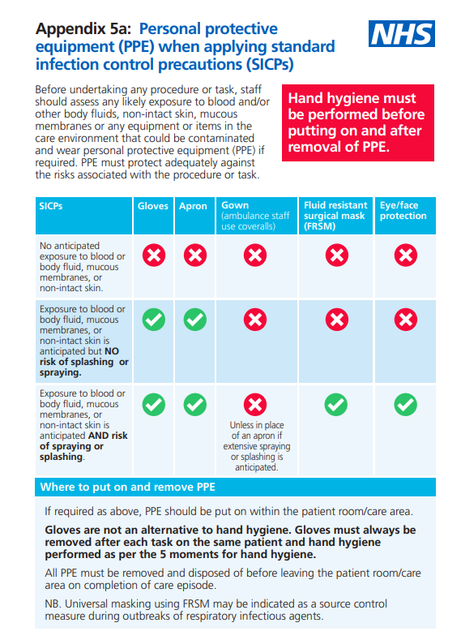

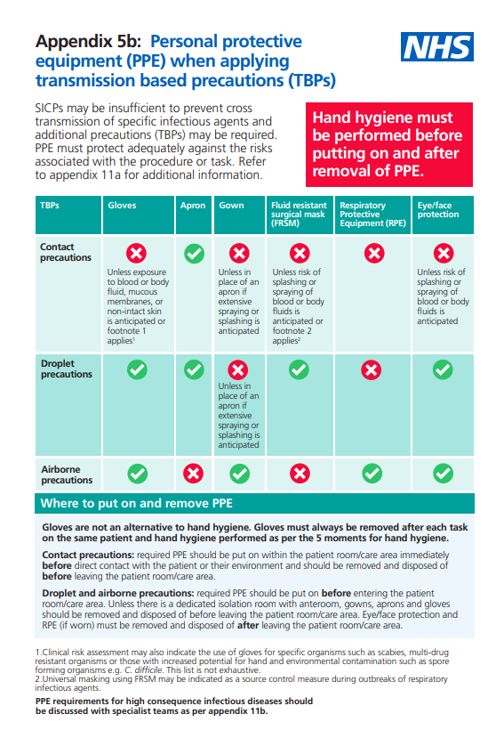

Cleaning
- No changes to our current general cleaning regimes.
- We continue to encourage the cleaning of shared devices (phones, computers etc.) as good practice between use with Clinelle green multi wipes.
- Hand hygiene requirements prior to entering and leaving clinical areas will continue.

Visitor guidance
- Unrestricted visiting to our patients will continue.
Air conditioning and fans
- Air conditioning can be used.
- Use of fans is allowed. These must be taken apart and cleaned between patient use.
- HSE video advice on ventilation: https://www.youtube.com/watch?v=6RGxWMaP8PA

 | IIR Mask  Required | Additional information
Shop, Retails and DC staff and volunteers | No | Follow government guidance.
IPU and Community staff providing face to face care less than 1 metre | No | Do not come to work if unwell or symptomatic.  and follow government hospice guidance.
Rehab and Wellbeing team and outpatient staff providing face to face care less than 1 metre | No
Visitors | No  (unless risk assessed and required) | All visitors are requested not to visit if they have symptoms or are unwell.
Patients | No | Follow government testing guidance regarding if symptomatic and prior to admission.
Car sharing H@H and CHC Team | No
Nonclinical on site GHH and EGC Teams | No
All shop and retail teams | No
Corridors & communal areas  GHH and EGC | No

References and Useful links
https://www.gov.uk/guidance/coronavirus-covid-19-testing-for-hospice
https://www.gov.uk/guidance/reducing-the-spread-of-respiratory-infections-including-covid-19-in-the-workplace
https://www.gov.uk/guidance/people-with-symptoms-of-a-respiratory-infection-including-covid-19
https://www.gov.uk/guidance/ventilation-to-reduce-the-spread-of-respiratory-infections-including-covid-19
https://www.gov.uk/guidance/living-safely-with-respiratory-infections-including-covid-19
https://www.gov.uk/guidance/people-with-symptoms-of-a-respiratory-infection-including-covid-19#what-to-do-if-you-have-symptoms-of-a-respiratory-infection-including-covid-19-and-have-not-taken-a-covid-19-test
https://assets.publishing.service.gov.uk/government/uploads/system/uploads/attachment_data/file/1071703/Reducing_household_transmission_English.pdf
https://www.england.nhs.uk/national-infection-prevention-and-control-manual-nipcm-for-england/
Linked document: GHHC guidance for visiting the inpatient unit and accessing our outpatient services
https://www.gov.uk/government/publications/covid-19-managing-healthcare-staff-with-symptoms-of-a-respiratory-infection/managing-healthcare-staff-with-symptoms-of-a-respiratory-infection-or-a-positive-covid-19-test-result

